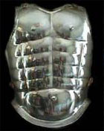
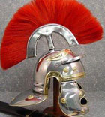

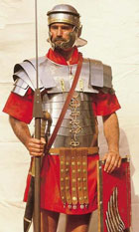

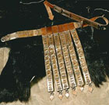
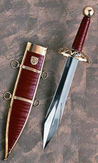

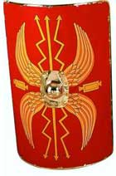

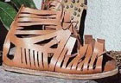

Ephesians 6:13-18

¹³Wherefore take unto you the whole armour of God, that ye may be able to withstand in the evil day, and having done all, to stand. ¹⁴Stand therefore, having your loins girt about with truth, and having on the breastplate of righteousness; ¹⁵And your feet shod with the preparation of the gospel of peace; ¹⁶Above all, taking the shield of faith, wherewith ye shall be able to quench all the fiery darts of the wicked. ¹⁷And take the helmet of salvation, and the sword of the Spirit, which is the word of God: ¹⁸Praying always with all prayer and supplication in the Spirit, and watching thereunto with all perseverance and supplication for all saints;

Psalms 5:3

My voice shalt thou hear in the morning, O LORD; in the morning will I direct my prayer unto thee, and will look up.

1 Peter 1:23

Being born again, not of corruptible seed, but of incorruptible, by the word of God, which liveth and abideth for ever.

Psalms 126:6

He that goeth forth and weepeth, bearing precious seed, shall doubtless come again with rejoicing, bringing his sheaves with him.

2 Corinthians 9:10

Now he that ministereth seed to the sower both minister bread for your food, and multiply your seed sown, and increase the fruits of your righteousness;)

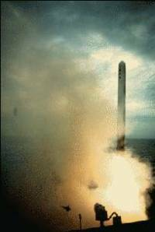
Tomahawk cruise missile is a winged, high subsonic speed surface-to-surface missile launched from surface ships or submarines against targets up to 700 miles away.

Aboard ship, Tomahawk is launched from a vertical launcher, while submarines launch Tomahawk from vertical tubes or from standard torpedo tubes.

After launch, Tomahawk follows its pre-programmed mission. The Block II version navigates by comparing what it "sees" on the ground to what is stored in its memory. Block III Tomahawks, first delivered in 1993, added satellite global positioning system (GPS) navigation to the missile's guidance system, thereby extending range, improving accuracy and adding time of arrival control.

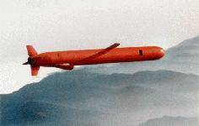
The Tomahawk program began in 1972, with production beginning in 1980. The missile's first combat use was in January 1991 in an attack against Iraq during Operation Desert Storm, providing a dramatic demonstration of its capabilities. Navy cruisers, destroyers, battleships and submarines launched 288 land-attack Tomahawks against weapon facilities, missile sites, and command and control centers. Its exemplary performance kept allied losses to a minimum and earned its reputation as the "weapon of choice" against high-value, heavily defended targets.

The Hughes Missile Systems Company is developing the next version Tomahawk which will be capable of reduced mission planning time, near perfect reliability, and even greater precision.

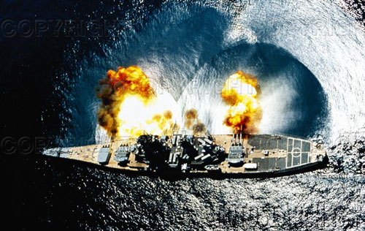

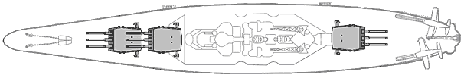
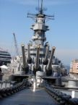
Battleship Iowa

Firing All Guns

Different types of prayer:
Barrels | Nine
Turrets | Three
Projectile Weight | Armor Piercing | 2,700 pounds
Projectile Weight | Bombardment | 1,900 pounds
Muzzle Velocity | Armor Piercing | 2,300 feet/second
Muzzle Velocity | Bombardment | 2,635 feet/second
Range  Gun Mount Elevation = 45 degrees | Armor Piercing | 36,900 yards (21 miles)
Range  Gun Mount Elevation = 45 degrees | Bombardment | 40,180 yards (22.8 miles)
Firing Cycle | 30 seconds
Supply Carried | 1,188 AP/HC
Crew Per Turret | 2 Officers & 170 Men

2 Kings 6:17
And Elisha prayed, and said, LORD, I pray thee, open his eyes, that he may see. And the LORD opened the eyes of the young man; and he saw: and, behold, the mountain was full of horses and chariots of fire round about Elisha.

