Psalms 90:10
The days of our years are threescore years and ten; and if by reason of strength they be fourscore years, yet is their strength labour and sorrow; for it is soon cut off, and we fly away.

Ephesians 5:15-16
¹⁵See then that ye walk circumspectly, not as fools, but as wise, ¹⁶Redeeming the time, because the days are evil.

Hebrews 9:27
And as it is appointed unto men once to die, but after this the judgment:

Redeem a coupon for $1 off the admission price of the Corn Maze at Stocker Farms:

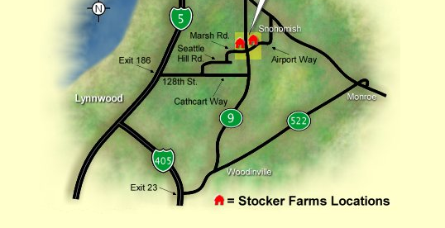
Print additional coupons: http://www.stockerfarms.com/page9807.asp

