Ephesians 4:8-10
⁸Wherefore he saith, When he ascended up on high, he led captivity captive, and gave gifts unto men. ⁹(Now that he ascended, what is it but that he also descended first into the lower parts of the earth? ¹⁰He that descended is the same also that ascended up far above all heavens, that he might fill all things.)

Psalm 68:18-19
¹⁸Thou hast ascended on high, thou hast led captivity captive: thou hast received gifts for men; yea, for the rebellious also, that the LORD God might dwell among them. ¹⁹Blessed be the Lord, who daily loadeth us with benefits, even the God of our salvation. Selah.

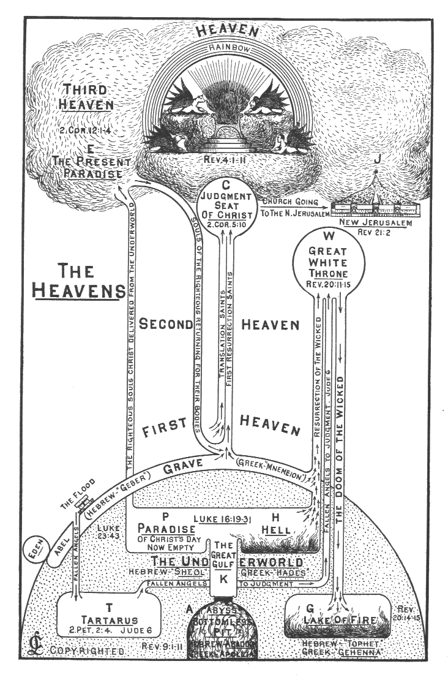 | Luke 16:22-26  ²²And it came to pass, that the beggar died, and was carried by the angels into Abraham's bosom: the rich man also died, and was buried; ²³And in hell he lift up his eyes, being in torments, and seeth Abraham afar off, and Lazarus in his bosom. ²⁴And he cried and said, Father Abraham, have mercy on me, and send Lazarus, that he may dip the tip of his finger in water, and cool my tongue; for I am tormented in this flame. ²⁵But Abraham said, Son, remember that thou in thy lifetime receivedst thy good things, and likewise Lazarus evil things: but now he is comforted, and thou art tormented. ²⁶And beside all this, between us and you there is a great gulf fixed: so that they which would pass from hence to you cannot; neither can they pass to us, that would come from thence.
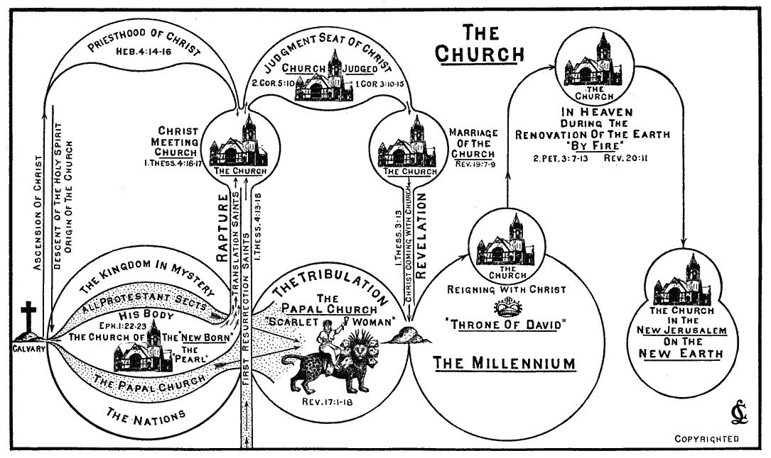
1 Thessalonians 4:13-18
¹³But I would not have you to be ignorant, brethren, concerning them which are asleep, that ye sorrow not, even as others which have no hope. ¹⁴For if we believe that Jesus died and rose again, even so them also which sleep in Jesus will God bring with him. ¹⁵For this we say unto you by the word of the Lord, that we which are alive and remain unto the coming of the Lord shall not prevent them which are asleep. ¹⁶For the Lord himself shall descend from heaven with a shout, with the voice of the archangel, and with the trump of God: and the dead in Christ shall rise first: ¹⁷Then we which are alive and remain shall be caught up together with them in the clouds, to meet the Lord in the air: and so shall we ever be with the Lord. ¹⁸Wherefore comfort one another with these words.

Philippians 3:20-21
²⁰For our conversation is in heaven; from whence also we look for the Saviour, the Lord Jesus Christ: ²¹Who shall change our vile body, that it may be fashioned like unto his glorious body, according to the working whereby he is able even to subdue all things unto himself.

2 Corinthians 5:10
For we must all appear before the judgment seat of Christ; that every one may receive the things done in his body, according to that he hath done, whether it be good or bad.

Revelation 20:11-12
¹¹And I saw a great white throne, and him that sat on it, from whose face the earth and the heaven fled away; and there was found no place for them. ¹²And I saw the dead, small and great, stand before God; and the books were opened: and another book was opened, which is the book of life: and the dead were judged out of those things which were written in the books, according to their works.

